PROJECT REPORT

ON

**ONLINE JOB PORTAL**

BY

**Vaibhav V .Chindarkar**

UNDER THE GUIDANCE

OF

**Mr.Dawood Ansari**

IN PARTIAL FULFILLMENT OF

**DEGREE OF B.Sc. (INFORMATION TECHNOLOGY)**

**OF THE**

**UNIVERSITY OF MUMBAI**

**FOR THE ACADEMIC YEAR 2013-2014**

**YASHWANTRAO CHAVAN COLLEGE OF ARTS, SCIENCE AND COMMERCE**

**(KOPARKHAIRANE, NAVI MUMBAI.)**



**CERTIFICATE**

***This is to certify that Mr./Ms.____________________________***

***_______________________________has satisfactorily completed the project work on _________________________________________ for partial fulfillment of the 3 years Full Time Course Bachelor of Information Technology of the University of Mumbai for the year 2013-2014.***

Place: ______________

Date: ______________

*__________________________ __________________________*

***Internal Project Guide Head of Department***

*_________________________ _______________________*

***External Examiner*** ***Principal***

**ACKNOWLEDGEMENT**

We take great pleasure in submitting this project report carried in year of 2013-2014 in YASHWANTRAO CHAVAN COLLEGE OF ARTS, COMMERCE AND SCIENCE, Which is partial fulfillment of Bachelor of Science course in Information Technology, University of Mumbai.

We believe that however strongly a person claims about his success of the project being due to his own sole effort, there has been a guiding factor involved which has in some way or the other way helped him to rich his goal.

We thank Prof. Dawood sir for being a constant motivating and guiding force and helping us attain the highest possible standard for our project.

We are grateful to the Department of Information Technology for providing us the technical assistance and access to all facilities that aided us during the course of working on the project.

We would also like to express our gratitude to all our professor and lecturer and Principal, Yashwantrao chavan College of Arts ,Commerce and Science for supporting and encouraging us.

The success of our project was not at all possible without the extreme support of our parents, who are always a source of inspiration to us.

**Vaibhav V.Chindarkar**

**ABSTRACT**

The Project Entitled “Online Job Portal” is the proposed system to provide help to the job seeker and employers. It provides full support to the job finding in India. The Job seeker and employer both face a lot of problem in their finding matching jobs due to lack of knowledge about concerned area. As the name suggest this acts as finds job for those user who are going to find a job in particular area and want some initial knowledge about the different companies. The difference between those of manual job search and this job search is that it is in electronic form and quite interactive than the manual searching of jobs. Another difference is that it is cheaper and full supportive than that manual job search.

“Online Job search portal” is an automated web based computerized system which can gives full knowledge about each type of jobs and companies. This information may be about Job type, Company name and detailed information about it, and particular employers. It provides the guidance in the electronic form to the job seeker who is confused initially about their interested jobs.

**CONTENTS**

|  |  |  |
| --- | --- | --- |
| Serial No. | Particulars | Page No. |
| 1 | Chapter 1: Introduction | 07 |
| 2 | Chapter 2: Objective | 09 |
| 3 | Chapter 3: Scope   * Project Justification * Project scope objectives * Project scope description * Project scope assumption | 11 |
| 4 | Chapter 4: System Analysis   * Definition * Existing System * Limitation of Existing System * Proposed System * Advantages of Proposed System * Feasibility Study * Technical Feasibility * Economical Feasibility * Behavioral Feasibility * Software tools * Requirement Specification | 16 |
| 5 | Chapter 5: System Planning | 23 |
| 6 | Chapter 6: Logical Design  • Data Structure  • ER Diagrams  • Data Flow Diagrams  ▪ Context level DFD  ▪ 1st level DFD  ▪ 2nd level DFD  • Use case Diagram  • PERT Chart  • Form List | 27 |
| 7 | Chapter 7: User Interface Design | 29 |
| 8 | Chapter 8: Future Enhancement | 46 |
| 9 | Chapter 9: Conclusion | 70 |
| 10 | Chapter 10: Bibliography | 72 |

CHAPTER 1: INTRODUCTION

**Why I chose “Online Job Portal” topic**?

* In today’s competitive environment, getting jobs and searching for candidates assumes greater importance.
* I chose this topic to enable companies to meet the ongoing competition.
* Online Job Portal enables companies to search for the most eligible candidates, the man resource of a company, in well established and efficient manner.
* To encourage a diverse group of applicants.
* To reduce cumbersome, time consuming process of manual screening and reviewing resumes.
* To build strong hiring team.

**Problem statement**

Traditional recruitment process is costly and time consuming for both employers and job seeker due to following reasons:

* **Complexity of Data:**
* Incoming applications in various formats such as mail, fax and different job board format.
* Cumbersome filing and retrieval due to incompatible source of information.
* **Inability to filter:**
* Time consuming manual screening and reviewing of resumes.
* Wasting substantial amount of time in interviewing unqualified candidates.
* **Database and Data Mining:**
* No centralized database for information storage and retrieval.
* No data mining tool to locate candidate from previous hiring.
* **Control:**
* Difficulty in keeping track of hiring cost and activities.

**Contribution of this Project:**

* Instantaneous access to a wide pool of applicants
* Lessens the time taken to:
* Deliver the message to the targeted area.
* Set up an account.
* Better management due to electronic links since applicants can view:
* Opportunities
* Job descriptions and related details.
* Potential to submit letters and resumes online.
* Provides the employer an added target area with a wider variety of links.

**Limitations**

* Expensive in implementation for companies.
* Need for HR staff to have additional training to utilize new tools.
* Employer’s decision to hire job seeker based on their resume instead of face to face interview.
* Specialty job and high end jobs are difficult to categorize in the general work site.
* Many jobs can be categorized under many titles and still not provide enough efficient information to match the right candidate to the job.
* Personality of person is not valued
* Applicants are recruited by merely considering their resume to determine whether one has the required skills.

CHAPTER 2: OBJECTIVE

* The objective of the Online Job Portal is to develop a system using which job applicants and recruiters can communicate with each other.
* The purpose is to enable applicants to search for jobs in a convenient manner and to enable employers to find suitable candidates.
* The number of people registering themselves on job portals is growing every day.
* It surely is not without a reason that the popularity of job portals is rising.
* Their numerous benefits and easy access help people in utilizing their advantages.
* In today’s economy where the number of enterprises is constantly growing and people experience much more frequent job change given various options in career growth, job portals have surely proved as a blessing in disguise.
* Here’s how E- Business techniques can help:
* **Speed up the process:**

Eliminate the need to read through piles of resumes.

* **Reduce costs:**

Online Job posting is a fraction of the cost of advertising.

* **Reach special labor segments:**

Particular candidate such as hi-tech workers are most likely to use online methods.

* **Process Decisions:**

Online Job Search Portal offers automated services for every aspect of the recruiting process. But before small business owners to jump into the game, they need to make some important decision like:

* Does it make sense to automate the process in-house or use online service?
* Is it better to outsource parts of it?
* What function should you outsource and what should you retain in-house?
* How important is the cost of the function compared to the time it takes and the quantity of candidate identified?
* Additionally this system has following objectives:
* This portal aims to provide complete information about all the jobs and company related your profile.
* This portal provides all information about each and every job in area like computer hardware, computer software, export/import and so on.
* This portal gives good facility to job seeker to find the job according to his profile.
* Employer can also find job seekers resume according to their requirements.
* All the matched job details will be sending in the email address of the job seeker.
* Job seeker and employer both can edit their profile whenever they want and can save new details.
* This portal has good security and service.

CHAPTER 3: SCOPE

***PROJECT JUSTIFICATION***

* **WHY THIS PROJECT?**
* In today’s competitive environment, getting jobs and searching for candidates assumes greater importance.
* I chose this topic to enable companies to meet the ongoing competition.
* Online Job Search Portal enables companies to search for the most eligible candidates, the man resource of a company, in well established and efficient manner.
* To encourage a diverse group of applicants.
* To reduce cumbersome, time consuming process of manual screening and reviewing resumes.
* To build strong hiring team.
* **WHAT THIS PORTAL WILL SUPPOSE TO DO?**

The Proposed System works like automated job search which help in searching of good job to the job seeker and searching for a good resume to the employers. The main goal of the system is to motivate and give good service to the job seeker. Additionally this project following set of objective:

* This system aims to provide complete information about all the jobs and company related your profile.
* This portal gives the good service for the job seeker. He can find job according to his profile.
* This system has good security and services.
* This system provides the facilities of the job post facility so that the interested company can give their job vacancies in this website.
* This system has provided the search facilities so that a user, if wants to find quick information then he will get desired information quickly.
* Process will not take much time as compared to manual system.
* **WHO WILL INTERACT WITH THIS PORTAL?**

This portal will be used by following entity:

* Administrator
* Job Seeker
* Recruiters (Companies)

They will interact with the portal by following way:

* **ADMINISTRATOR:**
* Administrator is the owner of the system. Admin will perform checking process on regular basis.
* It is necessary that website should show current information, so Admin is responsible for update the system continuously.
* Apart from updating the system, the main function of admin is to handle the security of the system.
* Different types of Authentication and Authorization is performed for this purpose.
* He is the person that has right to take final decision about the website.
* **JOB SEEKER:**
* Job Seekers are the user or people that are looking for the jobs in the market.
* A user just has to fill in the details like Qualification details, Experience, Personal details, Skills. Users have to upload your resume on these portals, through which he will receive desired job offers.
* When user login he will redirect to job seeker home page. On that page he can update his information provided by him at the time of registration.
* He can also search job by four ways:
* Advanced job search
* By Location
* By Industry
* By Functional area.
* He can also apply for job.
* He can also change his current password.
* **EMPLOYER:**
* The recruiter has to register his company before upload job and download resumes of job seeker.
* When recruiters login he will redirect to employers home page. On that page he can update his profile provided by him at the time of registration.
* He can also search resume bye 2 ways:
* By Location
* By Industry
* He can also upload job vacancies for job seeker.
* He can also change his current password.

***PROJECT SCOPE OBJECTIVES***

* The objective of the Online Job Portal is to develop a system using which job applicants and recruiters can communicate with each other.
* The purpose is to enable applicants to search for jobs in a convenient manner and to enable employers to find suitable candidates.
* The number of people registering themselves on job portals is growing every day.
* It surely is not without a reason that the popularity of job portals is rising.
* Their numerous benefits and easy access help people in utilizing their advantages.
* In today’s economy where the number of enterprises is constantly growing and people experience much more frequent job change given various options in career growth, job portals have surely proved as a blessing in disguise.
* Here’s how E- Business techniques can help:
* **Speed up the process:**

Eliminate the need to read through piles of resumes.

* **Reduce costs:**

Online Job posting is a fraction of the cost of advertising.

* **Reach special labor segments:**

Particular candidate such as hi-tech workers are most likely to use online methods.

* **Process Decisions:**

Online Job Search Portal offers automated services for every aspect of the recruiting process. But before small business owners to jump into the game, they need to make some important decision like:

* Does it make sense to automate the process in-house or use online service?
* Is it better to outsource parts of it?
* What function should you outsource and what should you retain in-house?
* How important is the cost of the function compared to the time it takes and the quantity of candidate identified?
* Additionally this system has following objectives:
* This portal aims to provide complete information about all the jobs and company related your profile.
* This portal provides all information about each and every job in area like computer hardware, computer software, export/import and so on.
* This portal gives good facility to job seeker to find the job according to his profile.
* Employer can also find job seekers resume according to their requirements.
* All the matched job details will be sending in the email address of the job seeker.
* Job seeker and employer both can edit their profile whenever they want and can save new details.
* This portal has good security and service.

***PROJECT SCOPE DESCRIPTION***

* **HOW TO REGISTER WITH A JOB PORTAL?**
* **For Candidates:**

A candidate just has to fill in the details like Qualification details, Experience, Personal details, Skills. Candidate has to upload his/her CV on these portals, through which he/she will receive desired job offers. Job seekers are free to choose password which is easily remembered by him. Job seekers are also free to choose username provided that username must not be taken by other job seeker. (He will come to know whether the desired username is available or not by message).

* **For Employers:**

The Employers has to fill the registration form details like company name, company type, contact information etc. Employers are also free to choose username provided that username must not be taken by other employers. (He will come to know whether the desired username is available or not by message).

* **HOW JOB SEEKER WILL SEARCH JOB AND APPLY FOR THE JOB?**
* After successful registration, Job seekers are permitted to access job seeker area.
* Job seeker can search the job by 4 ways:
* Advanced job search
* By Location
* By Industry
* By Functional area.
* As soon as job seeker select the criteria and click on search button entire available job matching with those criteria will be shown to job seeker with apply option.
* Job seeker can apply for the job by clicking on apply button. As soon as job seeker clicks on apply button all the details of job seeker will be sent to selected company’s email address.
* **HOW EMPLOYERS WILL SEARCH CANDIADTE AND DOWNLOAD RESUME?**
* After successful registration, employers are permitted to access employer area.
* Employers can search resume bye 2 ways:
* By Location
* By Industry
* As soon as employer select the criteria and clicks on search button the entire available candidate matching with those criteria will be shown to employers with Download resume option.
* **WHAT IS THE ROLL OF ADMINISTRATOR?**
* Following are the task which will be managed by administrator:
* Manage Database
* He can view the reports of Employers, Job Seekers and uploaded job report.
* He can send mail to job seeker with available matching jobs for that job seeker
* He can also send mail to employers with available matching candidate for the job uploaded by him.

***PROJECT ASSUMPTIONS***

* The user should have sufficient knowledge about computers.
* The computer should have internet connection and Internet server capabilities.
* The users know the English language, as the interface will be provided in English.

CHAPTER 4: SYSTEM ANALYSIS

***DEFINITION OF SYSTEM ANALYSIS***

* System analysis is the detailed study of the various operations performed by the system and their relationship within and outside the system.
* Analysis is the process of breaking something into its parts so that the whole may be understood.
* System analysis concerned with becoming aware of the problem, identifying the relevant and most decisional variables, analyzing and synthesizing the various factors and determining an optional or at last a satisfactory solutions.
* During this a problem is identified, alternate system solutions are studied and recommendations are made about committing the resources used to the system.

***EXISTING SYSTEM***

* The present system requires applicants to search through News Papers and visual media for job opportunities.
* Applicants need to apply for jobs using conventional methods and appear for interview on a specified date at a specified location.
* Employers need to advertise the vacancies and sort all applicant details, conduct selection procedures and complete the formalities. This approach is tedious and requires much effort and resources.
* The job Seeker and employers both face a lot of problem in their finding matching job due to lack of knowledge about concerned area.

***LIMITATIONS OF EXISTING SYSTEM***

* The present system requires applicants to search through News Papers and visual media for job opportunities which is not interactive.
* It does not Provide Entire Information about the Company or Organization
* It is very Difficult for job seeker to find Perfect job for him/her according to his/her skill
* Also it is very costlier and not that much supportive as compared to it is in Electronic form.
* Process is time consuming.

***PROPOSED SYSTEM***

* The proposed system is a web based application which allows applicants and employers to register their details.
* Applicants can browse through the uploaded job that are posted by employers and can apply for the jobs online.
* Employers can browse through the posted resumes and select suitable candidates.
* Administrator will manage all databases. He will send mail to Job seeker of recommended jobs matching with his criteria.
* Administrator will also send mail to employers of recommended candidate with his criteria.

***ADVANTAGES OF PROPOSED SYSTEM***

The Proposed System works like automated job search which help in searching of good job to the job seeker and searching for a good resume to the employers. The main goal of the system is to motivate and give good service to the job seeker. Additionally this project following set of objective:

* This system aims to provide complete information about all the jobs and company related your profile.
* This portal gives the good service for the job seeker. He can find job according to his profile.
* This system has good security and services.
* This system provides the facilities of the advertisement so that the interested person / company can give their advertisement in this website.
* This system has provided the search facilities so that a user, if wants to find quick information then he will get desired information quickly.
* Process will not take much time as compared to manual system.

***FEASIBILITY STUDY***

* **TECHNICAL FEASIBILITY**
* Technical Feasibility includes whether the technology is available in the market for development and its availability.
* The assessment of technical feasibility must be based on an outline design of system requirements in terms of input, output, files, programs and procedures.
* This can be qualified in terms of volumes of data, trends, frequency of updating, cycles of activity etc in order to give an introduction of technical feasible.
* Online job search with its emphasis on a more strategic decision making process is fast gaining ground as popular outsourced function.
* **ECONOMICAL FEASIBILITY**
* This feasibility study present tangible and intangible benefits from the project by comparing the development and operational cost.
* The technique of cost benefit analysis is often used as a basis for assessing economical feasibility.
* This system needs some more initial investment than the existing system, but it can be justified that it will improve quality of service.
* Thus feasibility study should center along the following points:
* Improvements resulting over the existing method in terms of accuracy, timeliness.
* Cost comparison.
* Estimate on the life expectancy of the hardware.
* Overall objectives.
* Our project is economically feasible. It does not require much cost to be involved in the overall process. The overall objective is in easing out the recruitment processes.
* **Behavioral / Operational Feasibility:**
* This analysis involves how it will work when it is installed and the assessment of political and managerial environment in which it is implemented.
* People are inherently resistant to change and computers have been known to facilitate change.
* The new proposed system is very much useful to the users and therefore it will accept broad audience from around the world.

***SOFTWARE TOOLS***

**FRONT END: ASP.NET**

* ASP.NET is Microsoft’s server side scripting technology that enables scripts (embedded in web pages) to be executed by an internet server.

**HOW DOES ASP.NET WORKS?**

* When a browser requests an HTML file, the server returns the file.
* When a browser requests an ASP.NET file, IIS passes the requests to the AS.NET engine on the server.
* The ASP.NET engine reads the file, line by line, and executes the scripts in the file.

**WHY ASP.NET?**

* **Better language support:**
* Uses the ADO.NET for database connectivity.
* Supports full visual studio syntax.
* **Programmable Controls:**
* ASP.NET contains the larger set of HTML controls. Almost all HTML elements on a page can be defined as ASP.NET control objects that can be controlled by scripts.
* ASP.NET also contains a new set of object oriented input controls, like programmable list boxes, validation controls.
* A new data grid control supports sorting, data paging, and everything you expect from a dataset controls.
* **Event driven programming:**
* All ASP.NET objects on a webpage can expose events that can be proceeds by ASP.NET code.
* Load, click and change events handled by code makes coding much simpler and much better organized.
* **Increased performance – Compiler code:**
* The first request for an ASP.NET page on the server will compile the ASP.NET code and keep cached copy in memory.
* The result of this is greatly increased performance.
* **Easy Configuration and Deployment:**
* Configuration of ASP.NET is done with plain text files. Configuration files can be uploaded or changed while the application is running. No need to restart the server.

**WHAT IS NEW IN ASP.NET IN 4.0?**

The focus of Microsoft’s latest **ASP.NET 4**.**0** mainly has been on improving the performance and Search-engine Optimization (SEO). In this article, I'll be taking a look at what I think are the most important new features in ASP.NET 4.0:

* Output cache extensibility
* Session state compression
* View state mode for individual control
* *Response.RedirectPermanent* method
* Routing in ASP.NET
* Increase the URL character length
* New syntax for Html Encode
* Predictable Client IDs
* *Web.config* file refactoring
* Auto-Start ASP.NET applications
* Improvements on Microsoft Ajax Library

**BACKEND: SQL SERVER 2005**

* At the 2011 Professional Association for SQL Server (PASS) summit on October 11, Microsoft announced that the next major version of SQL Server (codenamed "Denali"), would be SQL Server 2005. It was released to manufacturing on March 6, 2012.
* It was announced to be the last version to natively support OLE DB and instead to prefer ODBC for native connectivity.
* SQL Server 2012's new features and enhancements include Always On SQL Server Failover Cluster Instances and Availability Groups which provides a set of options to improve database availability, Contained Databases which simplify the moving of databases between instances, new and modified Dynamic Management Views and Functions, programmability enhancements including new spatial features, metadata discovery, sequence objects and the THROW statement, performance enhancements such as Column Store Indexes as well as improvements to On Line and partition level operations and security enhancements including provisioning during setup, new permissions, improved role management, and default schema assignment for groups.
* Microsoft has introduced SQL Server 2012 to the world and it's time for IT professionals to start to come to speed on what's new in this highly anticipated version of SQL Server.
  1. **AlwaysOn Availability Groups** -- This feature takes database mirroring to a whole new level. With AlwaysOn, users will be able to fail over multiple databases in groups instead of individually. Also, secondary copies will be readable, and can be used for database backups. The big win is that your DR environment no longer needs to sit idle.
  2. **Windows Server Core Support**-- If you don't know what Windows Server Core is, you may want to come up to speed before Windows 8 (MS is making a push back to the command line for server products). Core is the GUI-fewer versions of Windows that uses DOS and PowerShell for user interaction. It has a much lower footprint (50% less memory and disk space utilization), requires fewer patches, and is more secure than the full install. Starting with SQL 2012, it is supported for SQL Server.
  3. **Columnstore Indexes** – This is a cool new feature that is completely unique to SQL Server. They are special type of read-only index designed to be use with Data Warehouse queries. Basically, data is grouped and stored in a flat, compressed column index, greatly reducing I/O and memory utilization on large queries.
  4. **User-Defined Server Roles** -- DBAs have always had the ability to create custom database role, but never server wide. For example, if the DBA wanted to give a development team read/write access to every database on a shared server, traditionally the only ways to do it were either manually, or using undocumented procedures. Neither of which were good solutions. Now, the DBA can create a role, which has read/write access on every DB on the server, or any other custom server wide role.
  5. **Enhanced Auditing Features** -- Audit is now available in all editions of SQL Server. Additionally, users can define custom audit specifications to write custom events into the audit log. New filtering features give greater flexibility in choosing which events to write to the log.
  6. **SQL Azure Enhancements** -- These don't really go directly with the release of SQL 2012, but Microsoft is making some key enhancements to SQL Azure. Reporting Services for Azure will be available, along with backup to the Windows Azure data store, which is a huge enhancement. The maximum size of an Azure database is now up to 150G. Also Azure data sync allows a better hybrid model of cloud and on-premise solutions.
  7. **PowerView** -- You may have heard of this under the name "Project Crescent" it is a fairly powerful self-service BI toolkit that allows users to create mash ups of BI reports from all over the Enterprise.

***REQUIREMENT SPECIFICATION***

* **Minimum Server side requirements:**
* Processor: Pentium 4 (P4) or higher version
* RAM: Minimum 256 RAM
* Hard disk space: Minimum 5 GB
* Operating System: Windows XP or higher version of windows OS operating system
* **Software:**
* SQL Server
* .NET Framework
* IIS 5.0 above
* ASP.NET enabled
* **Minimum Client side requirements:**
* Processor: Pentium 4 (P4) or higher version
* RAM: Minimum 64 MB
* Operating System: Windows XP or higher version of windows OS or any other operating system
* Web Browser
* **Development Tools:**
* Visual Studio 2010
* SQL server 2005
* CSS Builder
* **Scripting Technology:**
* HTML
* Java Script

CHAPTER 5: PROJECT PLANNING

* Project planning is performed basically in the large organization where it requires effective management to control and to find the desired result.
* Project planning has following steps:
* Acquiring and organizing the tools and resources for the project.
* Preparation of well defined schedule for events of the projects.
* Proper evaluation of progress of project development.
* Establishing various standards for the project by which we can find the standard output.
* Our project has been going through this type of project plan.
* **GANTT CHART:**
* In the Gantt chart we show the time spent for each phase of the software development. Gantt charts are a project-planning tool that can be used to represent the timing of tasks required to complete a project. Because Gantt charts are simple to understand and easy to construct, they are used by most project managers for all but the most complex projects.
* In a Gantt chart, each task takes up one row. Dates run along the top in increments of days, weeks or months, depending on the total length of the project. The expected time for each task is represented by a horizontal bar whose left end marks the expected beginning of the task and whose right end marks the expected completion date. Tasks may run sequentially, in parallel or overlapping.
* As the project progresses, the chart is updated by filling in the bars to a length proportional to the fraction of work that has been accomplished on the task. This way, one can get a quick reading of project progress by drawing a vertical line through the chart at the current date.
* Completed tasks lie to the left of the line and are completely filled in. Current tasks cross the line and are behind schedule if their filled-in section is to the left of the line and ahead of schedule if the filled-in section stops to the right of the line. Future tasks lie completely to the right of the line.
* In constructing a Gantt chart, keep the tasks to a manageable number (no more than 15 or 20) so that the chart fits on a single page. More complex projects may require subordinate charts which detail the timing of all the subtasks which make up one of the main tasks.
* For team projects, it often helps to have an additional column containing numbers or initials, which identify that on the team is responsible for the task.
* Often the project has important events, which you would like to appear on the project timeline, but which are not tasks. For example, you may wish to highlight when a prototype is complete or the date of a design review.
* We planned our project using according to the Gantt chart as shown as follows:

|  |  |  |  |  |
| --- | --- | --- | --- | --- |
|  | DECEMBER | JANUARY | FEBRUARY | MARCH |
| PROJECT STEPS | DEC 1 DEC 15 DEC31 | JAN 1 JAN 15 JAN 31 | FEB 1 FEB 15 FEB 28 | MAR 1 MAR 15 MAR31 |
|  |  |  |  |  |
| System study and analysis |  |  |  |  |
| Understanding current system |  |  |  |  |
| Problem definition |  |  |  |  |
| Information gathering |  |  |  |  |
| Database design |  |  |  |  |
| Form design |  |  |  |  |
| Coding |  |  |  |  |
| Modification of forms |  |  |  |  |
| Testing |  |  |  |  |
| Implementation |  |  |  |  |
| Documentation |  |  |  |  |

***FIG 6.1 GANTT CHART***

CHAPTER 6: LOGICAL DESIGN

7.1 DATA STRUCTURE:

* In our project there are 6 tables in Job_Search Database:
* Admion_login
* User_Registration_table
* Employer_Registration
* Upload_Job
* Feedback
* Help

**7.1.1 Admin_login:-**

This table stores the admin login details.

|  |  |
| --- | --- |
| **Column name** | **Data type** |
| Username | nvarchar(50) |
| Password | Nvarchar(50) |
| Email_ID | Nvarchar(50) |

**7.1.2 User_Registration_table:-**

This table stores the details of job seeker details like login details, Contact details, Educational details, Upload resume etc. at the time of registration.

|  |  |
| --- | --- |
| **Column name** | **Data type** |
| First_name | varchar(50) |
| Last_name | varchar(50) |
| Username (Primary key) | Nvarchar(50) |
| Security_Question | Nvarchar(50) |
| Security_Answer | Nvarchar(50) |
| Password | Nvarchar(50) |
| Full_name | varchar(50) |
| Nationality | Varchar(50) |
| Current_Location | Varchar(50) |
| Other_Location | Varchar(50) |
| Mobile_number | bigint |
| Gender | Varchar(6) |
| Basic _Graduation | Varchar(50) |
| Other_BG | Varchar(50) |
| Major_subject | varchar(50) |
| Other_major | varchar(50) |
| PG | Varchar(50) |
| Other_PG | Varchar(50) |
| PG_major_subject | varchar(50) |
| Other_PG_subject | Varchar(50) |
| Research_topic | Varchar(50) |
| Other_research_topic | Varchar(50) |
| Total_experience | Nvarchar(50) |
| Job_type | Varchar(50) |
| Desired_Location | Varchar(50) |
| Other_DL | Varchar(50) |
| Desired_industry | Varchar(50) |
| Other_Desired_industry | Varchar(50) |
| Functional_Area | Varchar(50) |
| Other_Functional | Varchar(50) |
| Key_skills | Nvarchar(MAX) |
| Resume_headline | Nvarchar(MAX) |
| Upload_Resume | Nvarchar(MAX) |
| Summery | Nvarchar(MAX) |
| Email_ID | Nvarchar(50) |
| Join_date | date |

**7.1.3 Employer_Registration:-**

Employer_Registration table stores the employer(company) details like contact person details, company details, login details etc.

|  |  |
| --- | --- |
| **Column name** | **Data type** |
| Username(Primary key) | Nvarchar(50) |
| Security_Question | Nvarchar(50) |
| Security_Answer | Nvarchar(50) |
| Password | Nvarchar(50) |
| Position | Nvarchar(50) |
| Email_ID | Nvarcha(50) |
| Contact_Number | Bigint |
| Company_name | Nvarchar(50) |
| Company_type | Varchar(50) |
| Category | Nvarchar(50) |
| Office_Address | Nvarchar(50) |
| Comp_Email_ID | Nvarchar(50) |
| Comp_cont_noo | Nvarchar(50) |
| Company_Website | Nvarchar(50) |
| Registration_Date | Date |

**7.1.4: Upload_Job:-**

Upload_Job table stores the job uploaded by companies like company name, job location, industry, functional area, experience etc.

|  |  |
| --- | --- |
| **Column name** | **Data type** |
| Job_ID(Primary key) | int |
| Username | Varchar(50) |
| Name | Varchar(50) |
| Email_ID | Nvarchar(50) |
| Company_name | Nvarchar(50) |
| Industry | Varchar(50) |
| Job_Location | Varchar(50) |
| Functional_Area | Varchar(50) |
| Experience | Nvarchar(50) |
| Company_Type | Varchar(50) |
| Mobile_number | Bigint |
| Address | Nvarchar(MAX) |
| City | Varchar(50) |
| State | Varchar(50) |
| Pincode | Bigint |
| Country | Varchar(50) |
| Apply_here | Nvarchar(50) |
| Upload_On | Date |

**7.1.5 Feedback:-**

This table stores job seekers and employers feedback.

|  |  |
| --- | --- |
| Column name | Data type |
| Full_name | NVarchar(50) |
| Email_ID | Nvarchar(50) |
| Feedback | Nvarchar(MAX) |

**7.1.6 Help:-**

This table stores query about the job seekers and employers.

|  |  |
| --- | --- |
| Column name | Data type |
| Full_name | NVarchar(50) |
| Email_ID | Nvarchar(50) |
| Query | Nvarchar(MAX) |

7.2 Entity Relationship Diagram:

* The file system structure is the database structure of the system. It represents the storage system structure.
* An ER-Diagram (Entity Relationship Diagram) is a graphical model of the data needed by the system. This includes the entities about which information is stored and relationships among them. It is provided in structured analysis methods.

|  |  |
| --- | --- |
| Symbol | Convention |
|  | Entity |
|  | Relationship set |
|  | One to One Relation |
|  | One to Many Relation |
|  | Many to One Relation |
|  | Many to Many Relation |
|  | Attribute |

***Table: 7.2.1 Shapes used in ER diagram***

**7.2.1 Various entities used in our project:**

* An entity is an object in the real world that is distinguishable from other objects. Examples include the following: The C++ language, the address of the manager of the institution. It is often useful to identify a collection of similar entities. Such a collection is called as “Entity set”. Note that entity set need not be disjoint.
* An entity is a “thing” or “object” in the real world that is distinguishable from all set of objects. An entity set is a set of the same type that share same properties, or attributes.
* An entity is represented by a set of attributes.

JOB SEEKER

***Fig. 7.2.1 Entity Job Seeker***

Employers

***Fig. 7.2.2 Entity Employer***

Employers

ADMINISTRATOR

***Fig. 7.2.3 Entity Administrator***

JOB UPLOAD

***Fig. 7.2.4 Entity Job upload***

1

1

1

1

1

1

M

1

M

M

**EMPLOYER**

SEARCH

MANAGES

UPLOAD

MANAGES

MANAGES

SEARCH

**RESUME**

UPLOAD

**JOB SEEKER**

**ADMINISTRATOR**

1

M

M

M

**UPLOAD JOB**

***Fig. 7.2.ER Diagram***

7.3 DATA FLOW DIAGRAMS:

* Data Flow Diagramming is a means of representing a system by any level of detail with a graphic network of symbols showing data flows, data stores, data processes and data sources/destination.

7.3.1 Purpose / Objectives:

* The purpose of DFD is to provide a systematic bridge between users and system developers.
* The diagrams are:
* Graphical, eliminating thousands of words;
* Logical representations, modeling WHAT a system does, rather than physical models showing HOW it does it;
* Hierarchical, showing systems at any level of detail; and
* Jargon less allowing user understanding and reviewing.
* The role of Data Flow Diagramming is to have a commonly understood model of a system. The diagrams are the basic structured systems analysis. DFD have the objective of avoiding cost of:
* User/Developer misunderstanding of a system, resulting a need to a redo system or in not using the system.
* Having to start documentation from scratch when the physical system changes since the logical system, WHAT gets done, often remains the same when technology changes.
* System inefficiencies because a system a system gets “Computerized” before it gets “Systematized”.
* Being unable to evaluate system project boundaries or degree of automation, resulting in a project of inappropriate scope.
* A data flow diagram (DFD) is a graphical system model that shows all of the main requirements for an information system in one diagram: inputs and outputs, processes, and data storage. Everyone working on a development project can see all aspects of the system working together at once with DFD. That is one reason for its popularity. The DFD is also easy to read because it is graphical model.
* The DFD is mainly used during problem analysis. End Users, management, and all information systems workers typically can read and interpret the DFD with minimal training.

7.3.2 CONTEXT LEVEL DFD:

* The context level diagrams are initially drawn followed by the levels of DFD’s.
* A context diagram is a top level (also known as 0 ) data flow diagram. It only contains one process node (process 0) that generates the function of the entire system in relationship to external entities.
* The first level DFD shows the main process can be broken into further processes until you reach pseudo code.
* The context diagram provides a good overview of the scope of the system, showing the system in “context” but it does not show any detail about the processing that takes place inside the system.
* The context diagram for the Timetable Management system is shown below. The inputs & outputs of the store are shown in the figure. The diagram shows the external entities of the system & how the data that flows through the system. This helps in determining the basic functionalities.

ADMINISTRATOR

Request

Response

Response

JOB SEEKER

Request

EMPLOYER

Response

Request

**Fig. 7.3.1 Context level DFD / 0th level DFD**

7.3.2: 1st level DFD:

Request Result

Login

User

Response

Job Seeker

Job seeker info

Reg. info Employer info

Employer

User

Status

Login info

Login

Job Seeker

Availability of job seeker

Search criteria Job posting

Employer

User

Login

Search result

Vacancies info

Job seeker

Check User

Employer

Admin

Status

Authorizing

Access

Login

7.3.3: 2nd Level DFD:

User

Username Password

Login info Login

Status

Job Seeker

Login status

Job Seeker details

Job seeker info

Job Seeker

Role base

Login

Authentication on

Resume

Upload

Resume

Resume info

Employer info

Employer

Employer

Role base

Authentication Login

Add Job

Job

Vacancies

Company info

Job Seeker

Employer

Job info Job

Employer

Job seeker’s info Job Seeker

7.4 USE CASE DIAGRAM:

* A use case defines a goal-oriented set of interactions between external actors and the system under consideration. Actors are parties outside the system that interact with the system. An actor may be a class of users, roles users can play, or other systems.
* A use case is initiated by a user with a particular goal in mind, and completes successfully when that goal is satisfied.
* Thus, use cases capture *who* (actor) does *what* (interaction) with the system, for what purpose (goal), without dealing with system internals. A complete set of use cases specifies all the different ways to use the system, and therefore defines all behavior required of the system, bounding the scope of the system.

Job Seeker

Employer

Admin

***Fig. 7.4.1 Use case diagrams***

7.6 FORM LIST:

|  |  |
| --- | --- |
| FORM NAME | DESCRIPTION |
| HOME.aspx | Main Page of website |
|  |  |
| **ADMINISTRATION SECTION** |  |
| Candidate mail.aspx | Admin will send matching candidate profiles to employers |
| Change Password.aspx | Admin can change his password whenever he want |
| Employer_Report.aspx | Admin can see the employer report |
| Job_Mail.aspx | Admin will send recommended jobs information to Job seeker |
| Job_Seeker_report.aspx | Admin can see the job seeker report |
| Upload_Job_report.aspx | Admin can see the job report |
| View Profile.aspx | Admin can see entire information about job seeker, employers and uploaded jobs. |

**JOB SEEKER SECTION**

|  |  |
| --- | --- |
| User_Registration.aspx | User must have to register himself on website to become a member of website. |
| View Profile.asx | User can see his / her profile and can update the information. |
| Advanced_Search.aspx | User can search and apply for job by advanced search page. |
| Search by location.aspx | User can search the job by desired location and can apply for the job. |
| Search by Industry.aspx | User can search the job by desired industry and can apply for the job. |
| Search by Function.aspx | User can search the job by desired functional area and can apply for the job. |
| Job Seeker_Change Password.aspx | User can change the password whenever he wants. |

**EMPLOYER SECTION**

|  |  |
| --- | --- |
| Employer_Registration.aspx | Employer must have to register his company on the website to become a member of website. |
| View Profile.aspx | Employer can see his profile and update the information. |
| Access Resume.aspx | Employer can search for the candidates according to their requirement and download candidate’s resume. |
| Upload Job.aspx | Employer can upload the job on website. |
| Employer_change password.aspx | Employer can change his password whenever he wants. |

**OTHER PAGES**

|  |
| --- |
| E-Marketing.aspx |
| Expert’s_Advice.aspx |
| Help.aspx |
| how_to_get_idea_for_your_career.aspx |
| Life at work.aspx |
| Market yourself.aspx |
| Partner_Sites.aspx |
| Top 10 list.aspx |
| Aboutus.aspx |
| Forgot Password.aspx |
| Term of use.aspx |

CHAPTER 7: User Interface Design

**1. HOME.aspx (Main page of website)**

This is the main page of website.

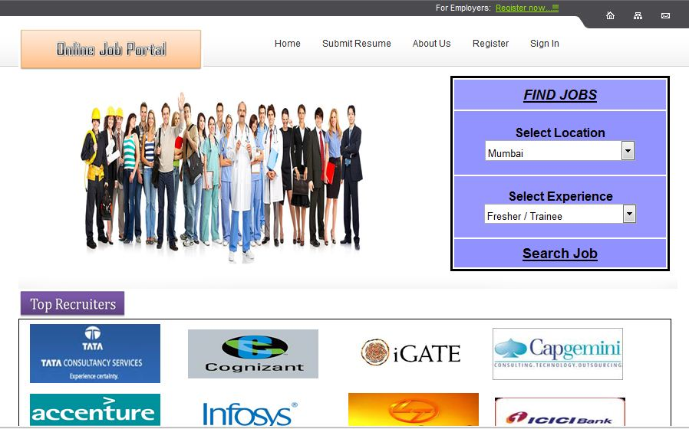

**2. HOME.aspx (Login section)**

Whenever user (Admin, Job seeker, Employer) goes to the website and if he wants to sign in to his account, he will click on “sign In” link located at top right corner of the main page.

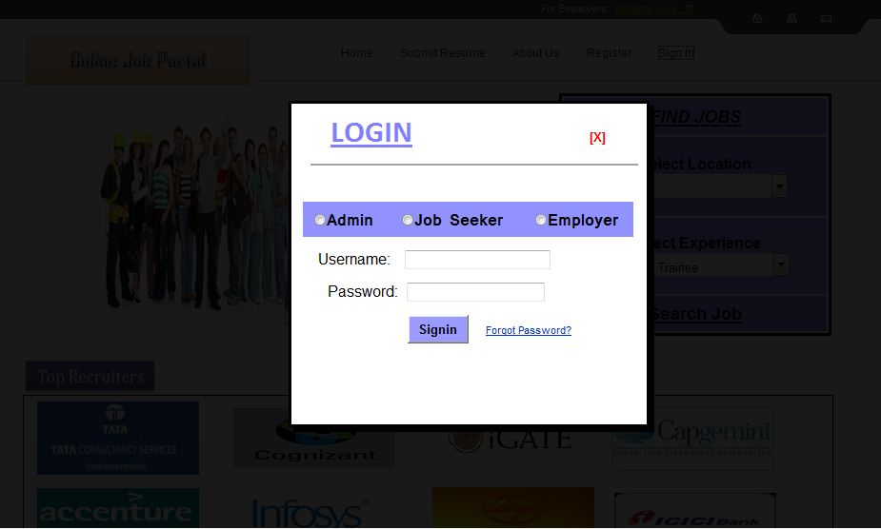

**3. HOME.aspx (When non registered user or registered user clicks on “Search job” button)**

When non registered user or registered user enters job location, experience and clicks on “Search job” button, all the uploaded job by the employer will be seen on another page.

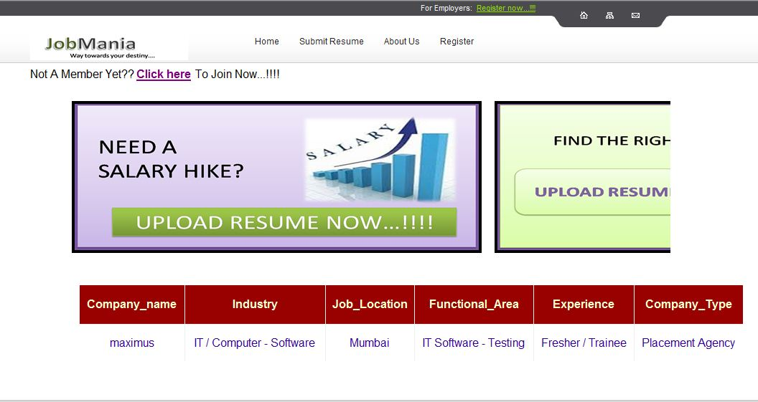

**4. view Profile.aspx (Admin)**

When Admin sign in to his account, he will redirect to the view Profile.aspx page. Admin will see employer, job seeker, job upload, feedback, help database.

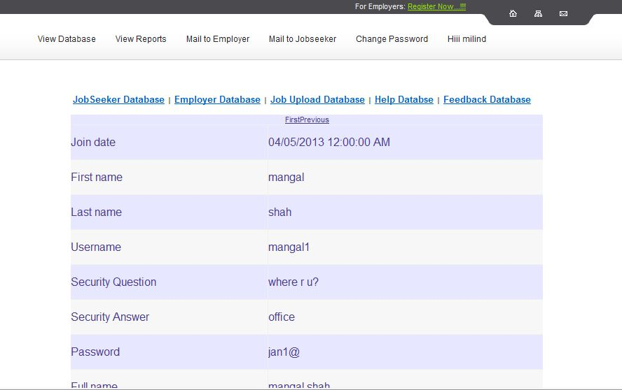

**5. Reports**

When user clicks on view reports link, 3 options will be displayed to admin: Job Seeker, Employer, Upload job. When user clicks on any of the 3 option the report of the corresponding option will be displayed to the admin.

**i) Job seeker report:**

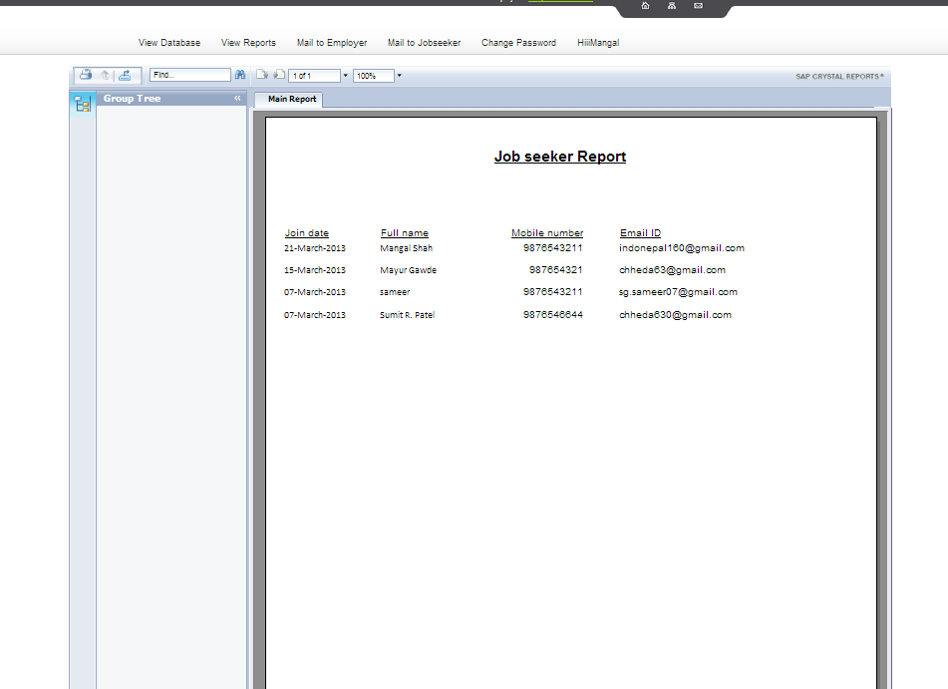

**ii) Employer reports**

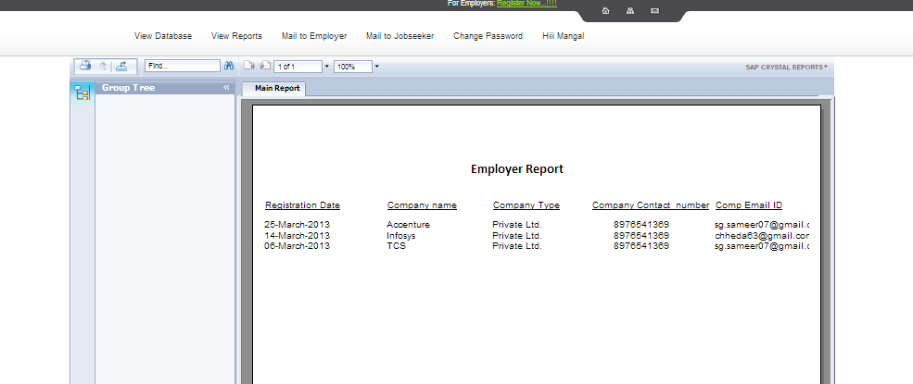

**iii) Job Upload reports**

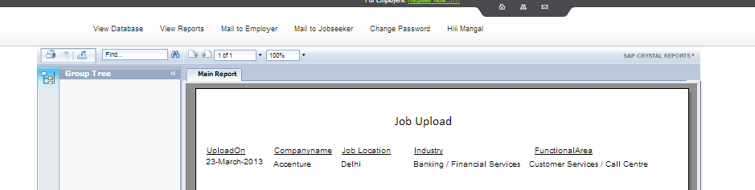

**6. Candidate mail.aspx**

When admin clicks on “**Mail to Employer**” link, all the uploaded job will be seen to admin.

When admin clicks on “select” link in grid view and clicks on “Recommended Resume” button, all the candidate matching with the requirements will be listed below.

Finally, when admin clicks on “**Send Recommended Resume**” button, all the candidates details will be sent to the company’s email id.

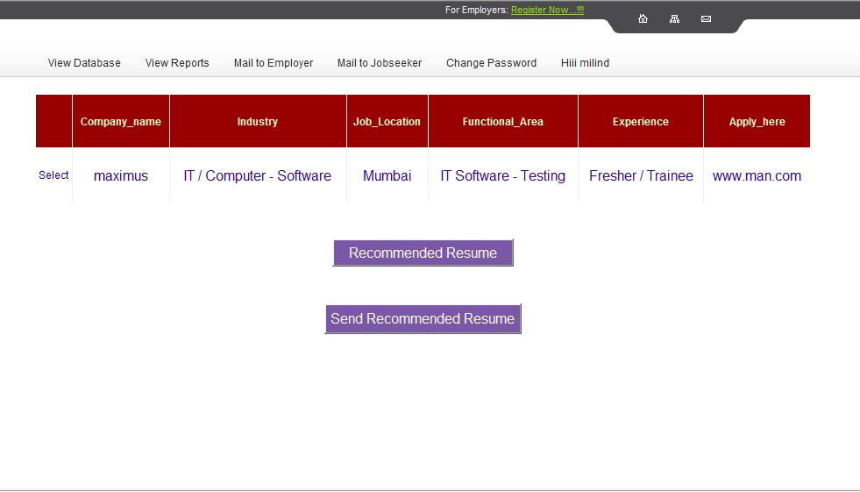

**7. Job_Mail.aspx**

When user clicks on “**Mail to Job Seeker**”, all the registered job seeker will be displayed.

Admin will select any one candidate and clicks on “**Recommended Jobs**” and all the jobs matching with job seeker’s requirements will be listed below.

Admin will clicks on “**Send Recommended Job Mail**”, all the information about the job will be sent to job seeker’s email id.

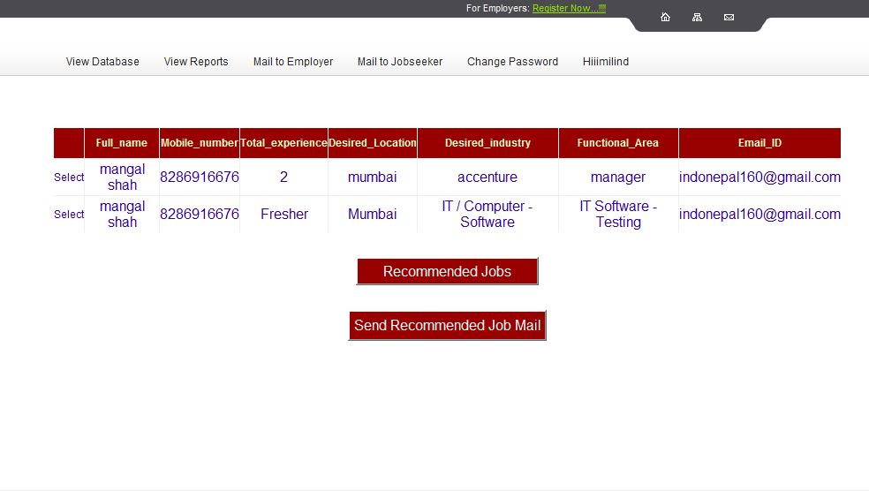

**8. Change Password.aspx**

When admin wants to change password of his account. He will simply click on “Change Password” link. By entering given details he can change his password easily.

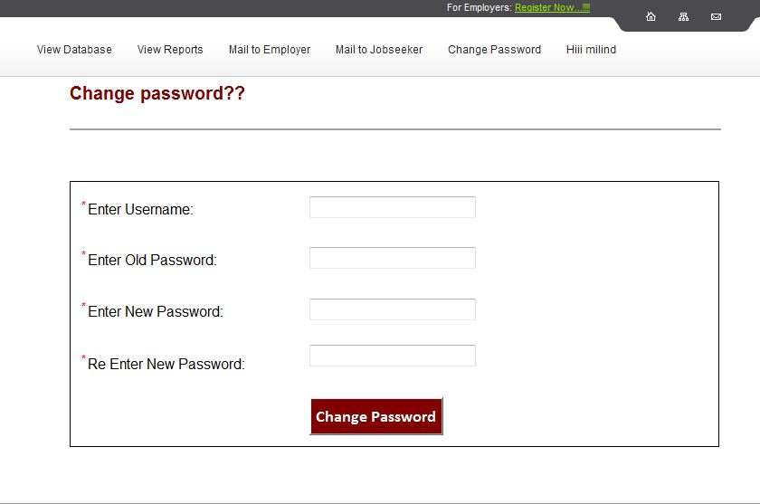

**9. User_Registartion.aspx**

When user wants to search and apply for the jobs, then he has to register himself to the website.

Job apply option will be available only to the registered users.

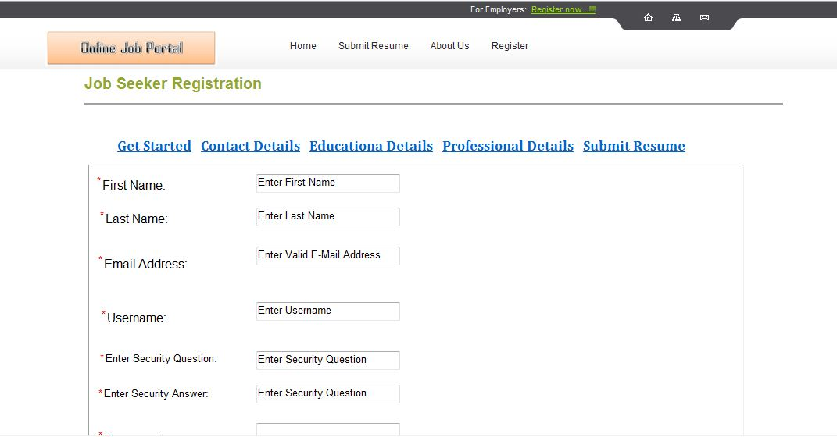

**10. View Profile.aspx**

When job seeker sign in to his account, this page will be displayed to him.

Job Seeker can not only view his profile but also update his profile whenever he wants.

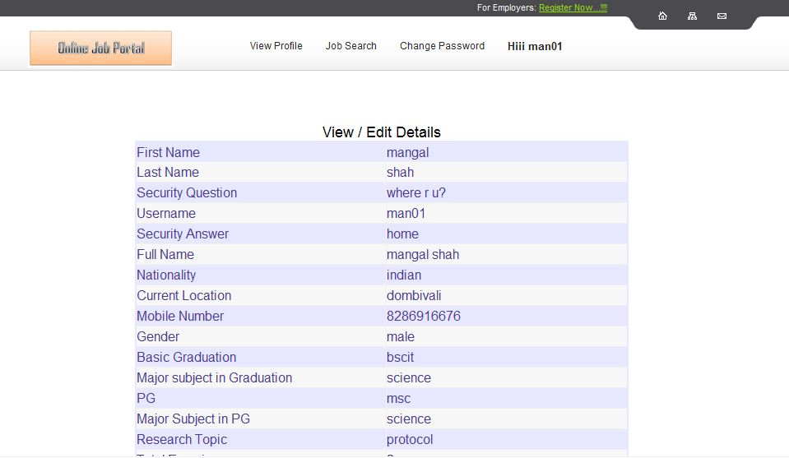

**11. Advanced_Search.aspx**

When job seeker clicks on “**Search Jobs**” link, he will redirect to the advanced search option.

User can search job by three four ways:

* By Advanced Search
* By Function
* By Location
* By Industry

When user search job by any of the above ways, all the available jobs matching with the requirements will be listed below.

User can apply for the desired job/s.

**i)By Advanced Search:-**

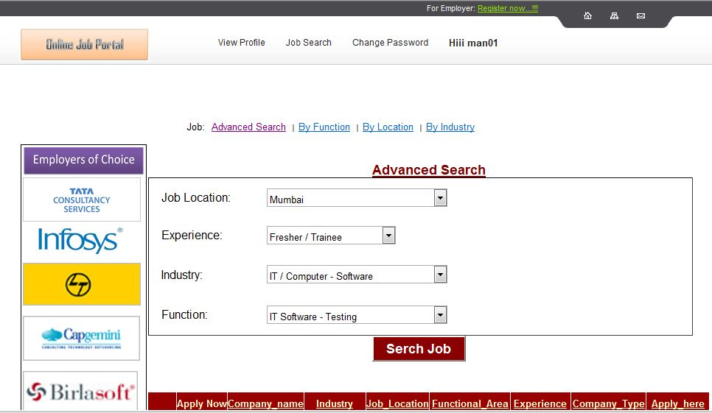

**Ii) By Function:-**

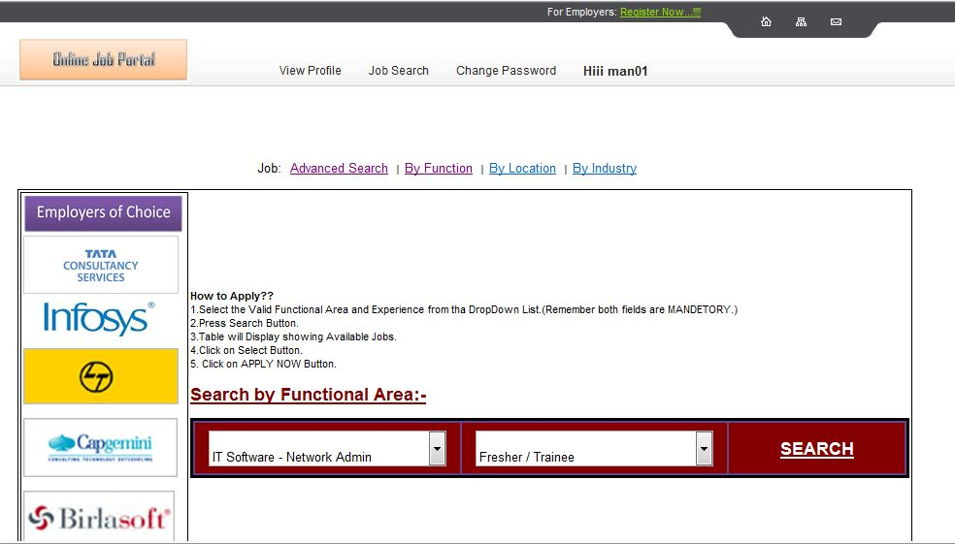

**iii) By Location:-**

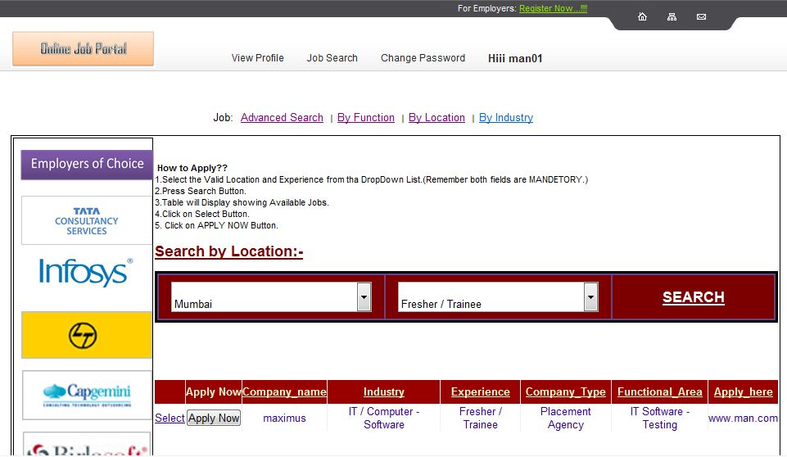

**iv) By Industry:-**

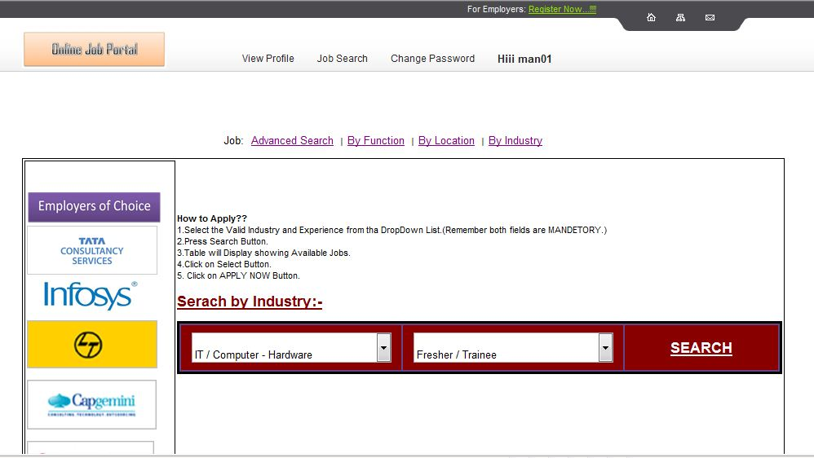

**12. Job_Seeker change Password.aspx**

When job seeker wants to change his account password, he can do so by simply click on change password link and fill the required fields.

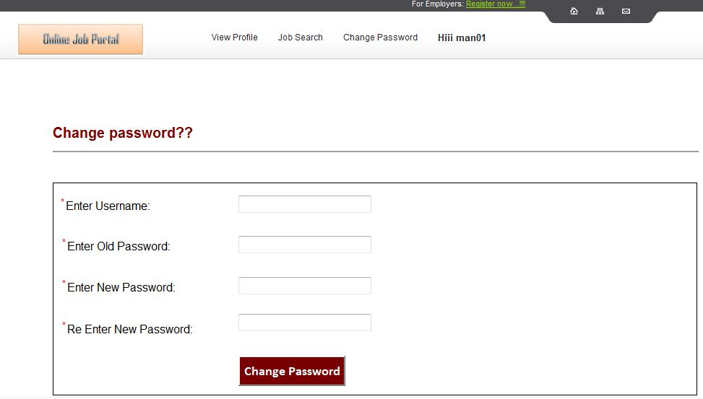

**13. Employer Registration.aspx**

When any employer who wants to search the resume or find the perfect candidate for the jobs or wants to advertise the job, he has to register his company to the website then only he can perform the above tasks.

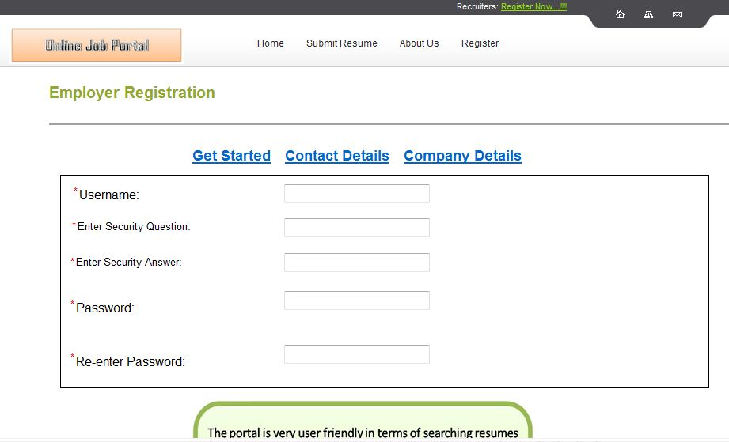

**14. View Profile.aspx**

When employers sign in to his account, he will be redirect to this page.

Employers not only view their profile but also update information whenever they want.

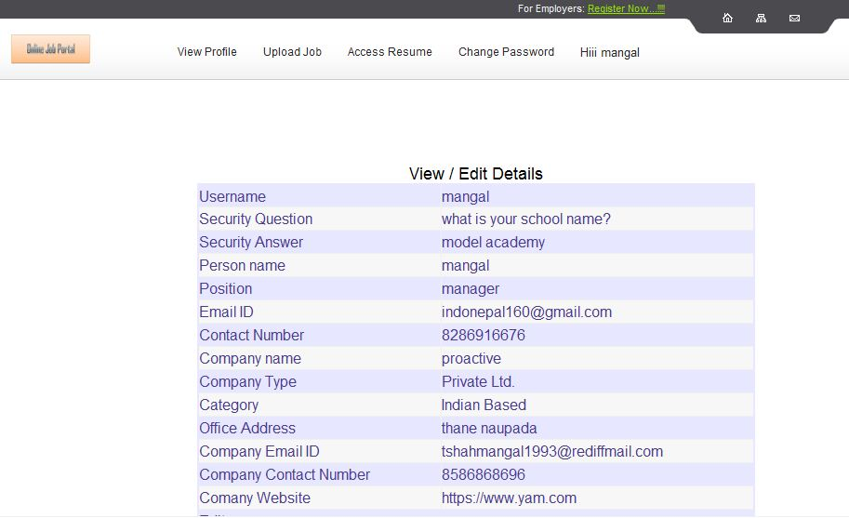

**15. Upload Job.aspx**

When employer clicks on upload job link, he can perform two tasks:

1) He can upload the new job by filling the given form of upload job.

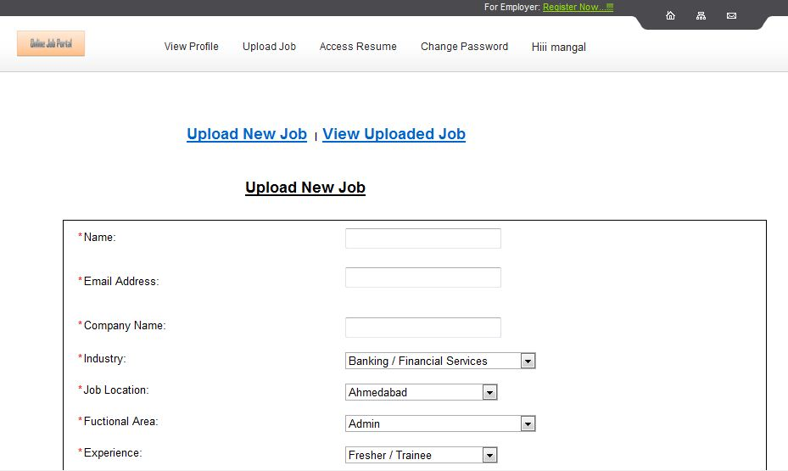

2) He can also see the uploaded job by him. He can update or delete the uploaded job whenever he wants.

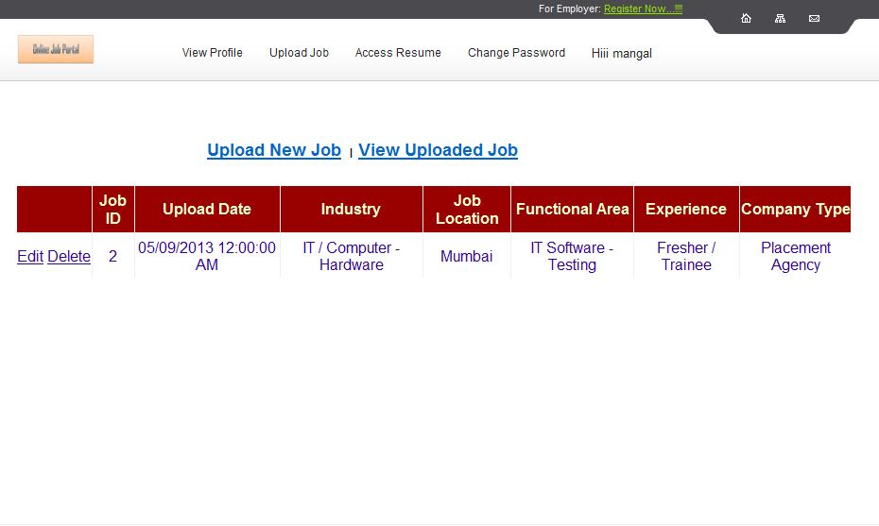

**16. Access Resume.aspx**

When employer clicks on Access Resume link he will be redirect to Access Resume.aspx page.

Employer can find the resume by location or by functional area.

When user fills the required details and click on search button, all the available candidates matching with the requirements will be listed below along with the resume.

Employer can download the resume of desired candidate/s.

**i) By Location:-**

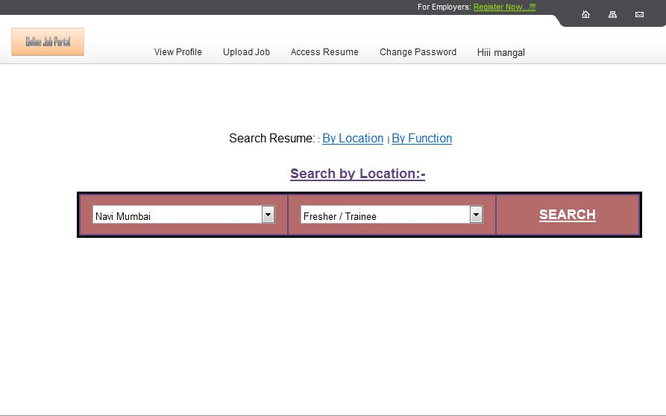

**17. Employer_Change Password.aspx**

When employer wants to change his account password, he can do so by click on change password link.

He has to fill the required details.

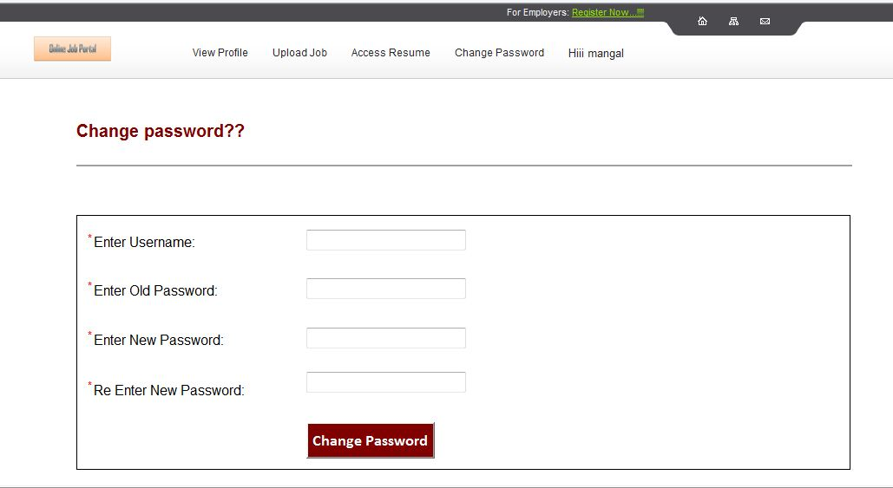

**18. Feedback section**

Feedback form is given to job seekers and employers to collect the feedback about website, service etc. to enhance the website functionality.

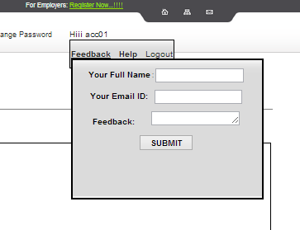

**19. Help Section**

Help form is given to job seekers and employers. When they have query or need help, they can mail their query to admin.

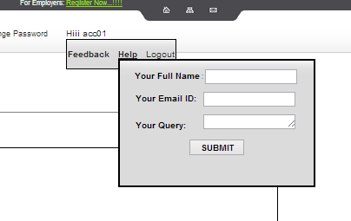

**19. Forgot Password.aspx**

When admin or job seeker or employer forgot their password, they can get their password by click on forgot password link.

User needs to select the category and has to provide correct email id given by him at the time of registration.

When User clicks on Reset Password button username and password will be sent to the given email id.

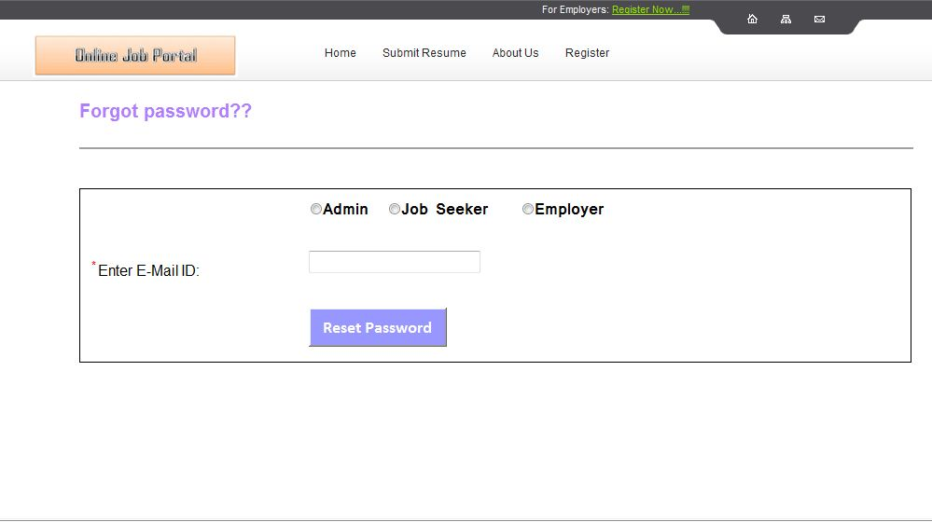

CHAPTER 8: FUTURE ENHANCEMENT

**•** “ONLINE JOB PORTAL” which is going to be developed, has been designed to work on large scale. As we have seen the difficulties in the manual system which is inconvenient and time consuming process well organized computerized implementation of job portal will remove all the limitations that arise in manual system and it will provide speedy retrieval of information despite having large size of database.

• We know that now a days every one want to do work very smoothly and fast because a lack of time.

• In the future we would like to extend this portal and try to give service vey less time and smoothly.

• Currently employer can access the database for free, but in future we will introduce various pay plans to access resume as well as advertise the job. Employers who want to access the resume database or upload their jobs have to first select the desired plan and according to plan they have to pay first. After that they can easily access the resume and upload the jobs.

For eg. Employer who wants to access the database for 2 days, they have to pay 500 and they can access 3 candidates resume.

• Feedback from the employers and job seeker are very important in order to enhance the website’s functionality. For that reason, we have included feedback form in job seeker and employer section. We will go through the feedback form and according to user’s wish I would try to make changes in the website.

• We have to use flash and extended use of multimedia animation so that we could provide information to the customer in attractive manner.

• We will also enhance the security of the website.

CHAPTER 9: CONCLUSION

* In making this website, we have learnt how actual project starts and the different phases of development.
* In manual job searching methodology both job seeker and employers have to face many difficulties. We studied their difficulties and try to overcome the problem in website.
* Job seeker can find the perfect jobs according to his qualification, skills and can apply for the jobs instantly.
* Employers can find the perfect candidate for the vacant place in company.
* Online job search portal saves huge time than the manual searching.
* It Reduces the Expenditure on security.
* Comfortable life and improved security.

CHAPTER 10: Bibliography

Reference Books:

* ASP.NET 3.5
* C# 2.0 Complete Reference
* ASP.NET Complete Reference

Internet Source:

* www.google.com
* www.monster.com
* www.naukri.com
* www.w3school.com
* Wikipedia